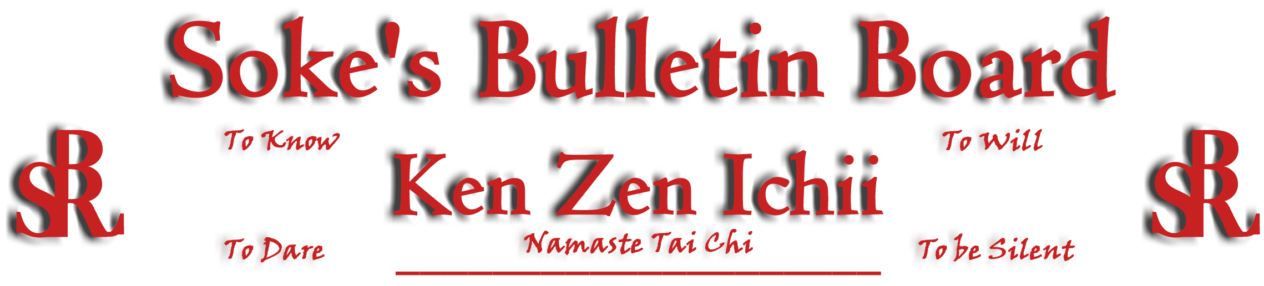
www.kenzenichii.com

December 2010
Promotions
Crush Fitness
Congratulations to Sensei Demi Bozas on earning the rank of Shodan

KZI – Tennessee
Congratulations to Christy O'Brian on obtaining Level 1 certification in Namaste Tai Chi.
Hudson Valley RyuTe Kan
Congratulations to Ricky Hyland on earning the rank of Green Belt

House of Soke
On behalf of the entire BSR/KZI system, thank you Sensei Thaje Jeanty for how well you have represented instructor Shihan Baker and Crush Fitness in competition (who are we).

My New Year’s wish is good health and wisdom for everyone…Soke Childress

House of Soke II
Thank you Sensei Bullock for coordinating the recent Blackbelt Workshop. It was well received and we are looking forward to the next one on December 18th.
BSR Modern Martial Arts School
Welcome new students, Darryl Douglas, Philip Banachiewicz, and Hazael Benvisrael.

Congratulations to Sensei Amur El on his new E book “Be Slim & Ripped.” I highly encourage students to read this book.

The dojo will be closed from December 24-January 3. We will be open to key holders & private lessons.

Please check out the new schedule for the 2011. Tai-Chi will now be on Wednesdays @ 7:30 pm.

Happy Holidays.

Sapphire Dragons
All is well with the Sapphire Dragons.

We wish everyone a very happy and joyous holiday.

Ken Zen Ichii Japan
All is going well.

KZI NEWSLETTER – December 2010
Page 2 of 2
KZI - Tennessee
All is going well.
We will be holding a self-defense workshop on Jan 22, for Friendship World Outreach (FWO). More details soon.

Crush Fitness
Many thanks to all who attended and participated in our 4 year Holiday Celebration on Sat. Dec 4th at 1:00pm. Thank you to all the parents, students, families, friends, KZI Sensei’s, Kyoshi’s and Shihan’s for continuing to support the KZI karate program at Crush Fitness.

Sensei Thaje Jeanty will be fighting on Sat 12/11 at the Mua Thai /Karate/Jui Jitsu championships in Danbury. Tickets are $25. Please see Shihan Baker of Sensei Jeanty for tickets.

There will be no classes on Dec 24th and 25th as well as Dec 31st and Jan 1st. There will be classes the day after the holiday, on Sun. Dec 26th and Jan 2nd at 11:30am.

Welcome New Students Ariana Adzovic and Amanda Moore

Friendly Reminder: Karate payment is due in the first Fri. or Sat. of each month. Thank you for your consideration.

Report cards: please submit a copy of your child’s report card to Shihan Baker. We not only strive for personal excellence but academic excellence as well. Every report card and all comments are read by Shihan Baker.

Hudson Valley RyuTe Kan
November 22, Ricky Hyland tested and was promoted to RokKyu, Green Belt. Congratulations Ricky!

Pearl’s of Wisdom
“If you believe you can do it you can”…Shihan Baker

Intuition
In his book, The Gift of Fear, a violence prediction expert Gavin de Becker describes the importance of using intuition to avoid danger. He describes different "messengers of intuition" such as overwhelming fear, a gut reaction, nagging feelings, or thoughts that just won't go away. Intuition usually happens before conscious awareness and is often ignored. It happens before anyone even puts, or tries to put their hands on you. A common belief is that, if a feeling can't be fully explained right away because of something concrete, it's probably not important. We discount intuition by telling ourselves, each other, and our children, "Don't be silly!" "You are such a worrier!" "It's really nothing!" "You are over-anxious!", “ You are over reacting”. Intuition is something to be listened to and is the first tactic in any self defense situation.

Editor’s Notes
Articles for the Ken Zen Ichii website and newsletter are being actively solicited. Anyone who wants to submit an article should contact Sensei Michael Calabrase at mcalabrase@bsrwarriors.com or the editor at Noah_Valle@hotmail.com, (818) 395-0757.

